Company Profile

Company : Hansa International Co., Ltd

Address : 57 Soi Ramkhamhaeng 30/1,
Ramkhamhaeng Rd., Hua Mark,
Bangkapi, Bangkok 10240
Thailand
Tel : 66-02732-3956 (Automatic)
0-2374-4596
Fax : 66-02732-3188
Email : hansa@hansa-boiler.com
Website : www.hansa-boiler.com
Shareholders : Thai 93%
German 7%
Registered Capital : 17.7 mill. Baht
Registration : 2 September 1982

History

Hansa International Co.,Ltd. was found in 1983 and handled technical equipment from Germany.

In 1988 we started to represent some wellknown German companies :-
- Babcock-Omnical Industrial GmbH
for steam boilers

- Konus Kessel GmbH
for thermal fluid heaters

- Babcock Anlagen AG
for dryers and complete plant

In 1990 we got further trust to represent
- Eberhard Hoesch & Sohne GmbH
for filter presses & agitators

- Pumpenfabrik Wangen GmbH
for ecentrical screw pumps

- we started our boilers’ assembly in Thailand

- we started to build our own workshop to manufacture steam boilers, pressure vessels, and ash handling equipment in Nakornratchasima under
joint-venture with German Babcock.

- we started our production in Nakornratchasima

- German Babcock got into insolvent
We decided to do our business in Thailand and separate then from German Babcock.

Product and Technology

We represent nowaday :-

- ALLGAIER Process Technology GmbH for screening machines and driers

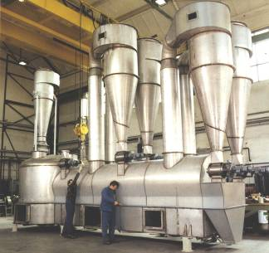

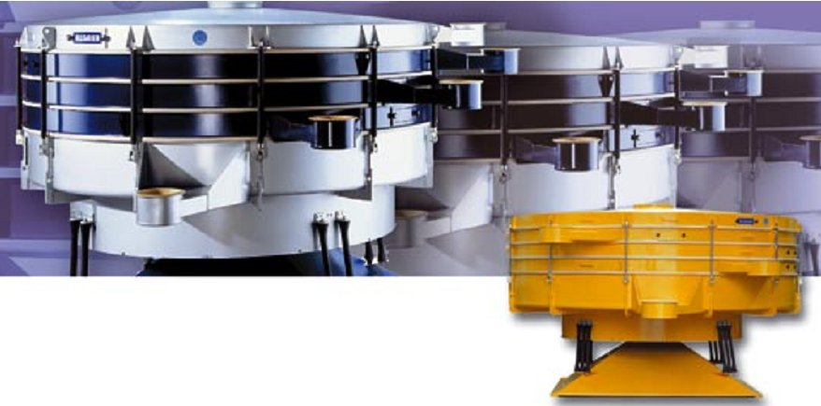

- Classen Apparatebau Wiesloch GmbH for thermal fluid heaters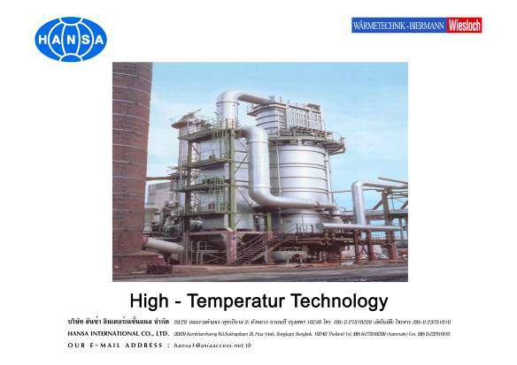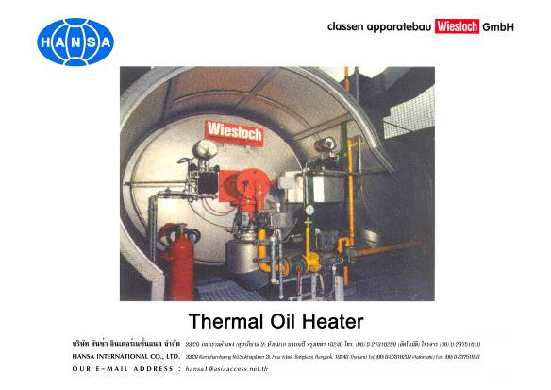

- Larsson AD/Sweden for starch equipment and starch process

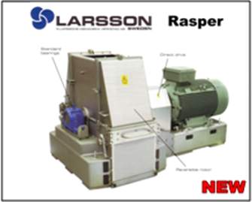

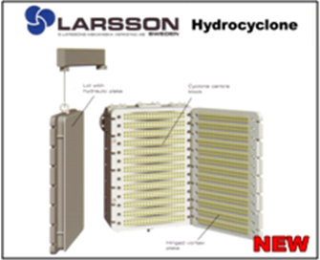

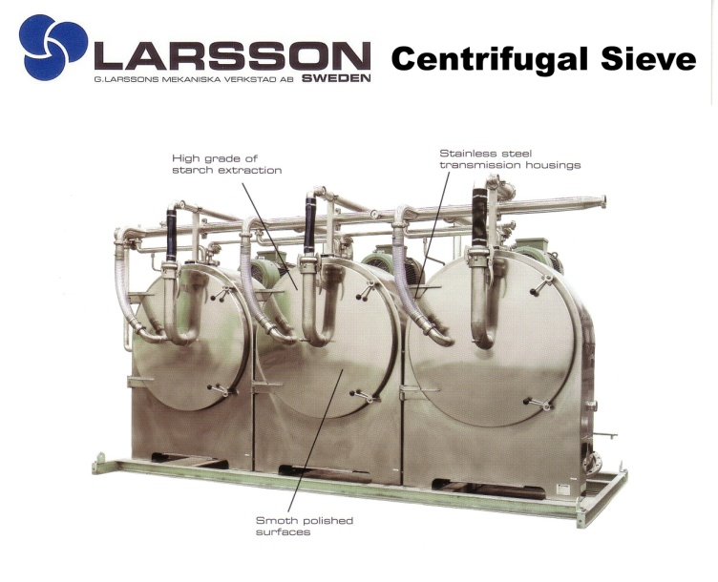

- NEMA Waermetauscher GmbH for fins tubes heat-exchangers

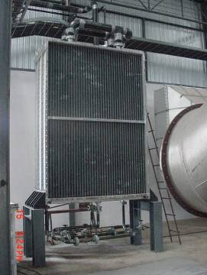

- TLT-Turbo GmbH for industrial fans

- Hansa Intertech Co.,Ltd. our own factory for manufacturing of three pass steam boilers with capacity up to 20 t/h and with maximum design pressure up to 16 bar.
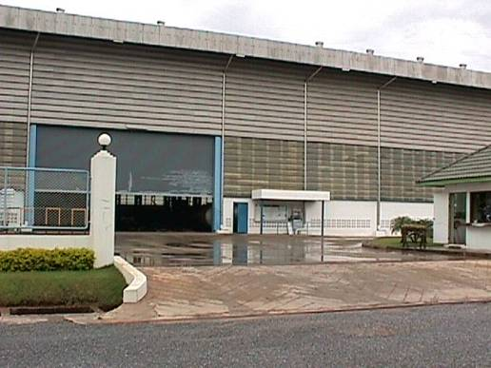

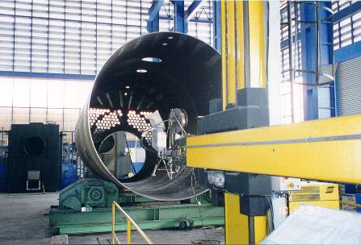
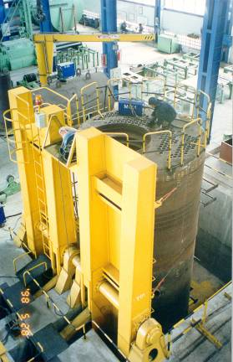

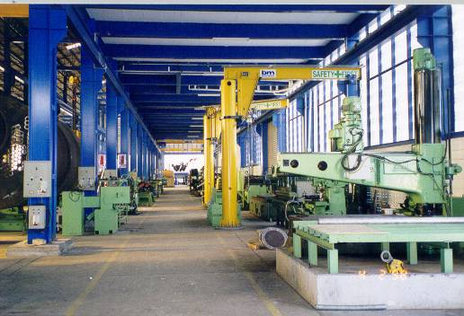

We also manufacture waste heat recovery boiler for firing with bio-mass (solid fuel) with capacity up to 15 t/h.

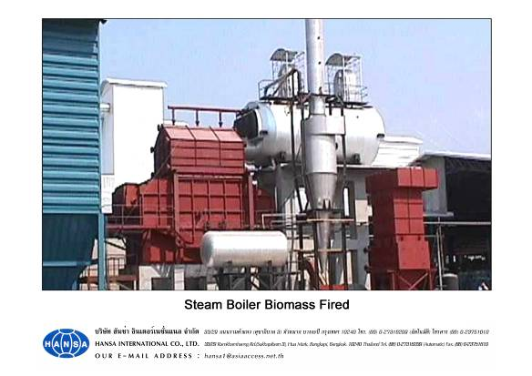
Catagories of Fire tube Steam Boiler Plant